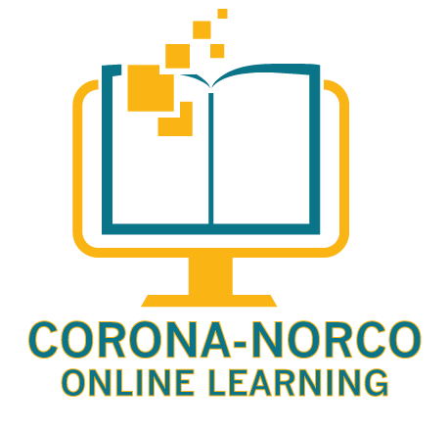
S Course-Based Independent Study
Corona-Norco Unified School District

COURSE WEBSITE: cnusd.owschools.com

PROGRAM DESCRIPTION: Odysseyware is an online-based method of delivering course material for students wishing to complete courses for school credit without the confines of a traditional classroom. Students will complete work at home through the Odysseyware website.

INSTRUCTOR CONTACT INFORMATION:

Subject Area | Teacher | Email | Remind
Mathematics | Brandon Kaan | brkaan@gmail.com | @kaanmathsc
Language Arts | Sarah Brown (CBIS)  Nathan Theune | sarahbrown.cnusd@gmail.com  theunelanguagearts@gmail.com | @CBISBrown  @odysseyla
Science | Mr. Nogales  Brandon Kaan | nogalesscience@gmail.com  brkaan@gmail.com | @nogscience  @kaanmathsc
Social Science | Carolyn Mitchell (CBIS)  Andrew Tillakooh | cmitchellhistoryol@gmail.com  atillekooh@gmail.com | @ekb34g
Spanish | Andrea Rinderle | senorarinderle@gmail.com | @spanishol
Physical Education/Health | Eric VanderWeerd  Pete Toomey (CBIS) | evanderweerd15@gmail.com  toomeyhealth@gmail.com | @vwhealth  @hhtoom16
Business and Engineering & Technology | Scott Usher | scott.usher@cnusd.k12.ca.us | @usherol

COURSE METHODS MAY INCLUDE:
- Vocabulary activities
- Online course reading
- Labs/Activities/Projects
- Essays/Extended Responses
- Note-taking
- Online quizzes and exams

ATTENDANCE: Student attendance in each course is based on the lessons they are assigned for the week. Students are expected to log in to Odysseyware each day, and complete the assignments for the week by Sunday at 11:59pm.

GRADING SCALE:

A+ | 97% | B+ | 87% | C+ | 77% | D+ | 67% | F Below 60%
A | 93% | B | 83% | C | 73% | D | 63%
A- | 90% | B- | 80% | C- | 70% | D- | 60%

GRADING POLICY:

Category | % of Final Grade
Online Unit Activities (multiple-choice questions, short answer questions), Quizzes, Essays, Exams, Labs, Activities, Projects, etc. | 70
Notebook | 20
Communication | 10

ONLINE UNIT ACTIVITIES: Online unit activities are the assignments given through Odysseyware. Please adhere to the due dates given in Odysseyware as best you can, as these dates are individualized based on your enrollment date. All assignments for the week are expected to be completed by 11:59 pm on Sunday night of each week. If a student needs more time to complete the assignments for a week, they may request an extension, but this is not automatically given. Students must request this.

Grades from Odysseyware are not entered in Q until students have completed an entire unit of study. Grades for tests, quizzes, essays, and individual assignments are weighted in Odysseyware already, so they are not weighted separately in the Q system. Student grades in the Odysseyware console will look different than your grade in Q because units will show in Q as “not graded” until the day they are due, at which point they will show as graded and will count towards a student’s grade—finished or not. Student grades in Q are accurate; Odysseyware grades are not because they do not include all components of a student’s grade.

Some projects on Odysseyware may direct you to click on a link to complete a task in Canvas. You will earn a score for this project in Canvas, but your score will be manually entered for such assignments.

The entire course should be completed by June 2, 1017.

NOTEBOOK: One component of your grade is to keep a detailed notebook. You are required to take a full page of notes for each lesson in Cornell-note format.. Each page of notes must include the following information written in blue or black pen: Subject, title of lesson, unit and lesson number and the date. Notes must be turned in to your teacher at the end of each unit. After completing the unit test, you will be required to send your teacher an electronic copy of your notes using the app DocScan. Since you may use notes on your quizzes and exam (aside from the final), it is to your benefit to keep a detailed notebook.

COMMUNICATION: It is critical that you communicate with your instructors. This is non-negotiable. Students are expected to stay in regular contact with their teachers via text, Remind, email, or another acceptable form. Students are required to communicate with their teachers via telephone, in person, or by any other LIVE audio visual connection no less than twice per calendar month to assess whether the student is making satisfactory educational progress.

UNIT TESTS AND SEMESTER EXAM: All unit-level and semester level exams must be taken in the presence of a proctor. The proctor may be a CNUSD administrator, certificated employee , classified employee or parent/guardian of the student. Students will be provided with a digital copy of a log which they will print out to keep a record of their proctored exams. This form will require the date of the exam, the title of the unit, the name of the person who proctored it along with their signature, and their relationship to the student. Completing an exam without the supervision of a proctor may result in invalidation of exam scores.

A SPECIAL NOTE ABOUT PLAGIARISM:
Plagiarism is a serious offense.
- The following counts as plagiarism:
  - Using another’s words with a website, book, article, etc. and passing it off as one’s own work without properly citing the material (either in quotes with a parenthetical citation at the end of the sentence, or paraphrased in a student’s own words with a parenthetical citation at the end of the sentence).
  - Copying another student’s work and passing it off as one’s own.
  - Having another student, a sibling, or other do work for you.
  - Essays that can be bought online. These are easily traced.
  - Copying material word for word from OW lessons—these still need to be cited.
  - Using online tools to complete your work for you (Google Translate, Sparknotes, etc.)
  - BASICALLY—IF YOU DIDN’T WRITE IT, DON’T TRY TO PASS IT OFF AS YOUR OWN.

I have read and understand the information presented in the Syllabus:

Name of Student:_____________________________________________

Signature: __________________________________________________

Date: _______________________________________________________

Name of Parent/Guardian:_____________________________________________

Signature: __________________________________________________

Date: _______________________________________________________

